Client-server Architecture

* Client-server architecture is a computing model in which the server hosts, delivers and manages most of the resources and services to be consumed by the client.
* This type of architecture has one or more client computers connected to a central server over a network or internet connection.
* Client-server architecture is also known as a networking computing model or client-server network because all the requests and services are delivered over a network.

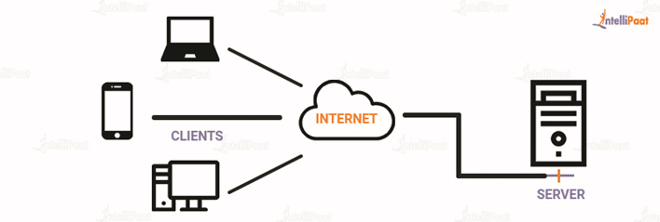

* Client server architecture is a computing model in which the server hosts, delivers, and manages most of the resources and services requested by the client.
* It is also known as the networking computing model or client server network as all requests and services are delivered over a network.
* The client-server architecture or model has other systems connected over a network where resources are shared among the different computers.